K-Means Clustering Overview
K-Means is an unsupervised machine learning algorithm, it is used for clustering data into K distinct clusters, also it optimises the intra-cluster similarity and maximises the inter-cluster separation.
Biswas et al. highlights that K-Means clustering algorithm is used for pre-processing of the data to improve the accuracy of the classification models and segmentation process helps analyse the data individually, the process is to divide the input data into k groups which must be disjoint [1].
Filipczuk et al. discuss a hybrid approach using K-Means for computing the optimal threshold achieved by minimising sum of squares for K clusters which are later used for segmentation. They emphasize that generating a correct cluster is the most important part [2].
Why K-Means?
K- Means is proved to be the most efficient and interpretable method for this dataset. Hierarchical clustering was computationally expensive and impractical for the dataset size. In context of clustering incomplete medical data, Goel et al. observed that K-Means performs reliably even when some data attributes are missing [3].
Algorithm:
- First step is to find the total number and clusters then, the clusters are created.
- Clusters are created by grouping set of data based on similarities in the dataset, which depends on the initial K-Means centroid.
- The centroid selection is the important process and is iterative, if this step goes wrong, it will in turn increase the number of iterations.
- The cluster position is determined by the shortest distance between the centroid and the document.[4]
Steps Implemented and Insights:
1. When we loaded the dataset and inspected it, there were no missing values and all features were numeric. Also normalised the data for better clustering performance using Standard Scalar which standardize features by removing the mean and scaling to unit variance.
2. Visualised the clusters using PCA for k values 3,4,5.
3. To determine the optimal number of clusters k, the Elbow method and the silhouette analysis was employed. Which involves plotting the value of inertia. Inertia is calculated by sum of squared distances between the data points and their cluster centroids for different values of k.
4. Elbow Method: The curve starts to flattening around k=4, Also this indicates a knee point which suggests that adding more points after k=4, will yield diminishing returns.
5. Silhouette Analysis: Although, k=2 gives the best score, it may oversimplify the data. Considering both the plots k=3 appears to be best value for k, which also gives a cluster purity of 0.792(79.2%).
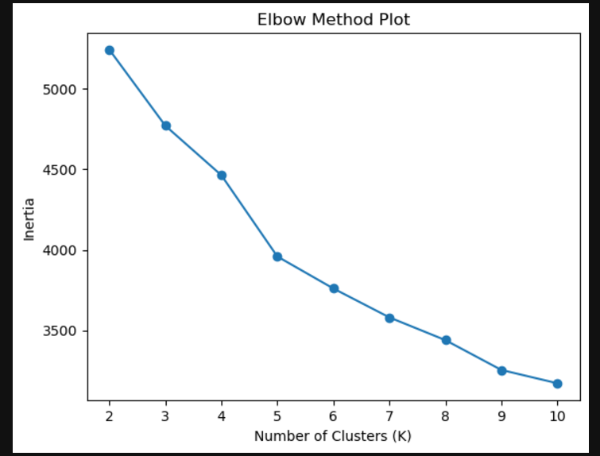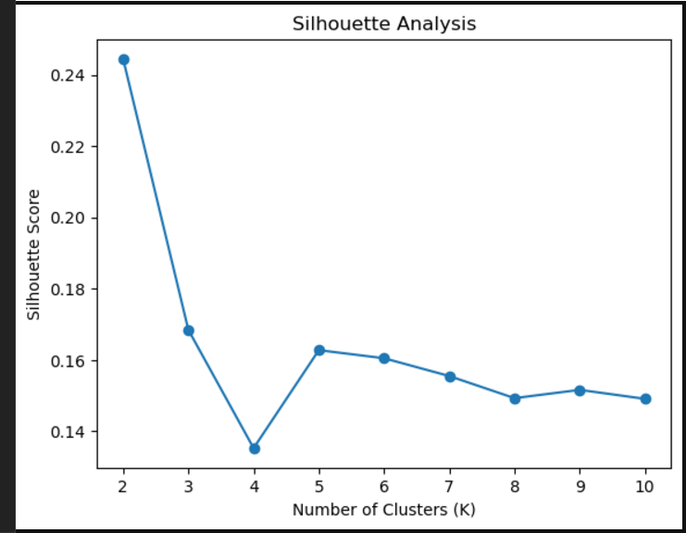
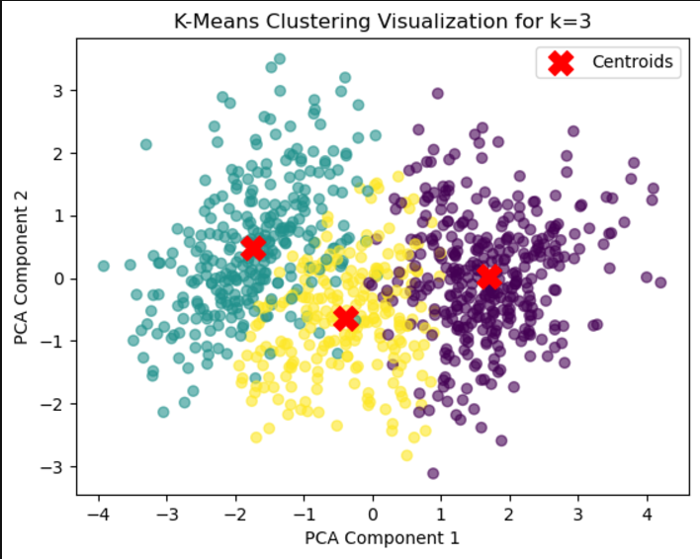
6. After which we created a new dataset with a new column called ‘cluster’ which has the values ranging from 0-2(k=3) clusters, also we did a cluster summary to identify distinct patterns and characteristics within each group.
7.Our findings from the summary: The clusters were named by considering both age and physiological characteristics, specifically maximum heart rate.
Cluster 0: “Older Men Group with Lower Heart rate”
Reason: Higher average age (57.7) years, Majority male (88.8%), Exercise-induced angina is common (85.43%), max-heart rate (121).
Cluster 1: “Younger Men/Women Group with Higher Heart Rate”
Reason: Average age (49.55), Balanced gender ratio (56.57% male), max-heart rate (154).
Cluster 2: “Middle-Aged Group with Moderate Heart Rate”
Reason: Average age (51.94), max-heart rate (138)
8. When we plot the likelihood of MI for each cluster it looks like people in cluster 0 have a much higher risk (89%) while the risk is much lower for those in cluster 1 (only 13%). Cluster 2 is somewhere in between, at around 55%. This tells us that people in cluster 0 may need the most attention for heart health.
Citations:
[1] A. Biswas and M. S. Islam, "Brain Tumor Types Classification using K-means Clustering and ANN Approach," 2021 2nd International Conference on Robotics, Electrical and Signal Processing Techniques (ICREST), DHAKA, Bangladesh, 2021, pp. 654-658, doi: 10.1109/ICREST51555.2021.9331115.
[2] Filipczuk, P., Kowal, M., Obuchowicz, A. (2011). Automatic Breast Cancer Diagnosis Based on K-Means Clustering and Adaptive Thresholding Hybrid Segmentation. In: Choraś, R.S. (eds) Image Processing and Communications Challenges 3. Advances in Intelligent and Soft Computing, vol 102. Springer, Berlin, Heidelberg, doi: 10.1007/978-3-642-23154-4_33.
[3] S. Goel and M. Tushir, "A Comparative study of different approaches for clustering of incomplete medical data," 2023 13th International Conference on Cloud Computing, Data Science & Engineering (Confluence), Noida, India, 2023, pp. 112-117, doi: 10.1109/Confluence56041.2023.10048818.
[4] C. Hayat, "Enhanced K-Means Clustering Approach for Diagnosis Types of Acne," 2021 2nd International Conference on Innovative and Creative Information Technology (ICITech), Salatiga, Indonesia, 2021, pp. 39-43, doi: 10.1109/ICITech50181.2021.9590124.

